

Name : Ayesha bibi
Reg No : FA25-BAI-010
Subject : OOP
Lab Assignment # 04
Submitted to :Mam Sajida Kalsoom

Lab Assignment # 04
Question # 01
Create the following GUI. You do not have to provide any functionality.
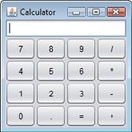
Solution:
import java.awt.*;
import javax.swing.*;
public class LabTask111 extends JFrame
{
public LabTask111()
{
JPanel p1=new JPanel();
p1.setLayout(new GridLayout(4,4,5,5));

for (int i=7;i<=9;i++)
{
p1.add(new JButton("" + i));
}
p1.add(new JButton("/"));
for (int i=4;i<=6;i++)
{
p1.add(new JButton("" + i));
}
p1.add(new JButton("*"));
for(int i=1;i<=3;i++)
{
p1.add(new JButton("" + i));
}
p1.add(new JButton("-"));
p1.add(new JButton("0"));
p1.add(new JButton("."));
p1.add(new JButton("="));
p1.add(new JButton("+"));

JPanel p2=new JPanel(new BorderLayout());
p2.add(new JTextField(),BorderLayout.NORTH);
p2.add(p1,BorderLayout.CENTER);
add(p2,BorderLayout.CENTER);
}

public static void main(String [] args)
{
LabTask111 frame=new LabTask111();
frame.setTitle("Calculator");
frame.setSize(400,250);
frame.setLocationRelativeTo(null);
frame.setDefaultCloseOperation(JFrame.EXIT_ON_CLOSE);
frame.setVisible(true);
}

}

Output:
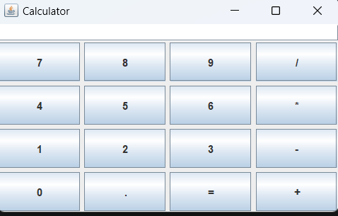
Question # 02
Create the following GUI. You do not have to provide any functionality
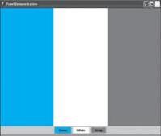
Solution:
import java.awt.*;
import javax.swing.*;

public class LabTask112 extends JFrame
{
public LabTask112()
{

JPanel p1 = new JPanel();
p1.setLayout(new GridLayout(1,3));

JPanel bluePanel = new JPanel();
bluePanel.setBackground(Color.BLUE);

JPanel whitePanel = new JPanel();
whitePanel.setBackground(Color.WHITE);

JPanel grayPanel = new JPanel();
grayPanel.setBackground(Color.GRAY);

p1.add(bluePanel);
p1.add(whitePanel);
p1.add(grayPanel);

JPanel p2 = new JPanel();

JButton b1 = new JButton("Blue");
b1.setBackground(Color.BLUE);

JButton b2 = new JButton("White");
b2.setBackground(Color.WHITE);

JButton b3 = new JButton("Gray");
b3.setBackground(Color.GRAY);

p2.add(b1);
p2.add(b2);
p2.add(b3);

add(p1, BorderLayout.CENTER);
add(p2, BorderLayout.SOUTH);
}

public static void main(String[] args)
{
LabTask112 frame = new LabTask112();

frame.setTitle("Colors");
frame.setSize(400,250);
frame.setLocationRelativeTo(null);
frame.setDefaultCloseOperation(JFrame.EXIT_ON_CLOSE);
frame.setVisible(true);
}
}

Output:
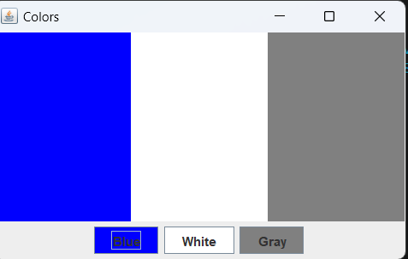

Question # 03
Create the following GUI. You do not have to provide any functionality
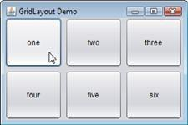
Solution:
import java.awt.*;
import javax.swing.*;
public class LabTask113 extends JFrame
{
public LabTask113()
{
JPanel p1=new JPanel();
p1.setLayout(new GridLayout(2,3,5,5));
p1.add(new JButton("one"));
p1.add(new JButton("two"));
p1.add(new JButton("three"));
p1.add(new JButton("four"));
p1.add(new JButton("five"));
p1.add(new JButton("six"));
add(p1);

}
public static void main(String [] args)
{
LabTask113 frame=new LabTask113();
frame.setTitle("GridLayout Demo");
frame.setSize(400,250);
frame.setLocationRelativeTo(null);
frame.setDefaultCloseOperation(JFrame.EXIT_ON_CLOSE);
frame.setVisible(true);
}
}

Output:
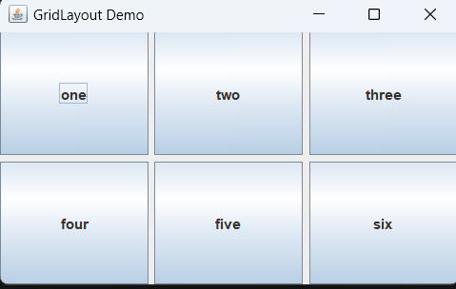

Question # 04
Create the following GUI. You do not have to provide any functionality.
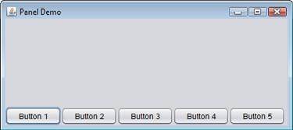
Solution:
import java.awt.*;
import javax.swing.*;

public class LabTask114 extends JFrame
{
public LabTask114()
{
JPanel p1 = new JPanel(new BorderLayout());

JPanel southPanel = new JPanel();

southPanel.add(new JButton("Button 1"));
southPanel.add(new JButton("Button 2"));
southPanel.add(new JButton("Button 3"));
southPanel.add(new JButton("Button 4"));
southPanel.add(new JButton("Button 5"));

p1.add(southPanel, BorderLayout.SOUTH);

add(p1);
}

public static void main(String[] args)
{
LabTask114 frame = new LabTask114();

frame.setTitle("BorderLayout Demo");
frame.setSize(500,250);
frame.setLocationRelativeTo(null);
frame.setDefaultCloseOperation(JFrame.EXIT_ON_CLOSE);
frame.setVisible(true);
}
}

Output:
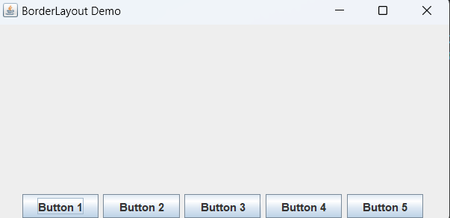

Question # 05

Create the following GUI. You do not have to provide any functionality.
Note: Use JScrollPane class for the creating the scroll pane.
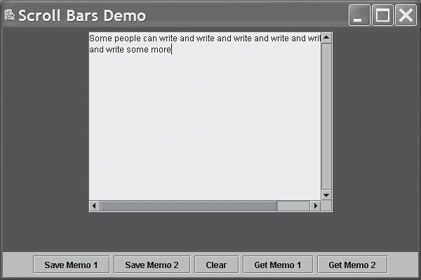

Solution:
import java.awt.*;
import javax.swing.*;

public class LabTask115 extends JFrame
{
public LabTask115()
{
JTextArea area = new JTextArea(50, 50);

area.setText("Some people can write and write and write and write and write and write some more and more and more and more and more and more and more and more");

area.setLineWrap(false);

JScrollPane s1 = new JScrollPane(
area,
JScrollPane.VERTICAL_SCROLLBAR_ALWAYS,
JScrollPane.HORIZONTAL_SCROLLBAR_ALWAYS
);

JPanel p1 = new JPanel();
p1.add(new JButton("Save Memo 1"));
p1.add(new JButton("Save Memo 2"));
p1.add(new JButton("Clear"));
p1.add(new JButton("Get Memo 1"));
p1.add(new JButton("Get Memo 2"));

add(s1, BorderLayout.CENTER);
add(p1, BorderLayout.SOUTH);
}

public static void main(String[] args)
{
LabTask115 frame = new LabTask115();

frame.setTitle("Scroll Bars Demo");
frame.setSize(600, 450);
frame.setLocationRelativeTo(null);
frame.setDefaultCloseOperation(JFrame.EXIT_ON_CLOSE);
frame.setVisible(true);
}
}
Output:
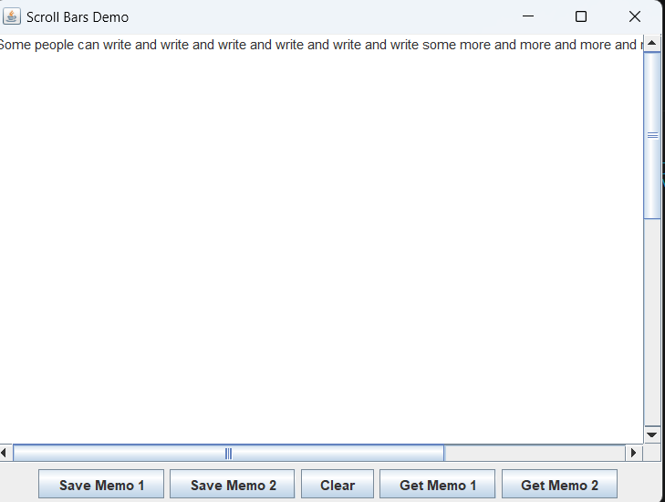

Question # 06
Create a frame with one label, one textbox and a button. Display the information entered in textbox on
button click.
Solution:
import java.awt.*;
import java.awt.event.*;
import javax.swing.*;

public class LabTask116 extends JFrame
{
JLabel l1 = new JLabel("Enter Text Below:");
JTextField t1 = new JTextField(20);
JButton b1 = new JButton("Show");

public LabTask116()
{
setLayout(new FlowLayout());

add(l1);
add(t1);
add(b1);

b1.addActionListener(new ActionListener()
{
public void actionPerformed(ActionEvent e)
{
l1.setText(t1.getText());
}
} );
}

public static void main(String[] args)
{
LabTask116 frame = new LabTask116();

frame.setTitle("Text Display");
frame.setSize(300,200);
frame.setLocationRelativeTo(null);
frame.setDefaultCloseOperation(JFrame.EXIT_ON_CLOSE);
frame.setVisible(true);
}
}
Output:
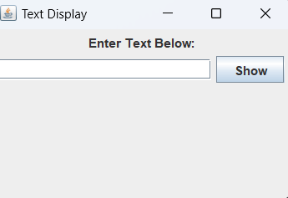

Question # 07
Create frames as follows:
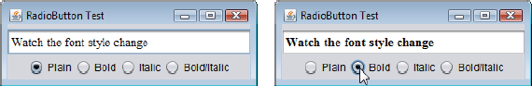
Solution:
import java.awt.*;
import java.awt.event.*;
import javax.swing.*;

public class LabTask117 extends JFrame
{
JTextField text;

public LabTask117()
{
setLayout(new FlowLayout());

text = new JTextField("Watch the font style change", 25);

JRadioButton b1 = new JRadioButton("Plain");
JRadioButton b2 = new JRadioButton("Bold");
JRadioButton b3 = new JRadioButton("Italic");
JRadioButton b4 = new JRadioButton("Bold/Italic");

// Panels for proper layout
JPanel p1 = new JPanel();
JPanel p2 = new JPanel();

p1.add(text);

p2.add(b1);
p2.add(b2);
p2.add(b3);
p2.add(b4);

add(p1);
add(p2);

ButtonGroup g1 = new ButtonGroup();
g1.add(b1);
g1.add(b2);
g1.add(b3);
g1.add(b4);

Font f1 = new Font("Serif", Font.PLAIN, 14);
Font f2 = new Font("Serif", Font.BOLD, 14);
Font f3 = new Font("Serif", Font.ITALIC, 14);
Font f4 = new Font("Serif", Font.BOLD + Font.ITALIC, 14);

text.setFont(f1);

b1.addItemListener(new ItemListener() {
public void itemStateChanged(ItemEvent e) {
text.setFont(f1);
}
});

b2.addItemListener(new ItemListener() {
public void itemStateChanged(ItemEvent e) {
text.setFont(f2);
}
});

b3.addItemListener(new ItemListener() {
public void itemStateChanged(ItemEvent e) {
text.setFont(f3);
}
});

b4.addItemListener(new ItemListener() {
public void itemStateChanged(ItemEvent e) {
text.setFont(f4);
}
});
}

public static void main(String[] args)
{
LabTask117 frame = new LabTask117();

frame.setTitle("Radio Button Font Change");
frame.setSize(450,200);
frame.setDefaultCloseOperation(JFrame.EXIT_ON_CLOSE);
frame.setVisible(true);
}
}
Output:
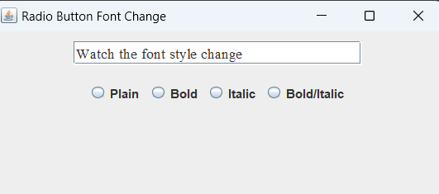

Question # 8
Create Frames as follows.
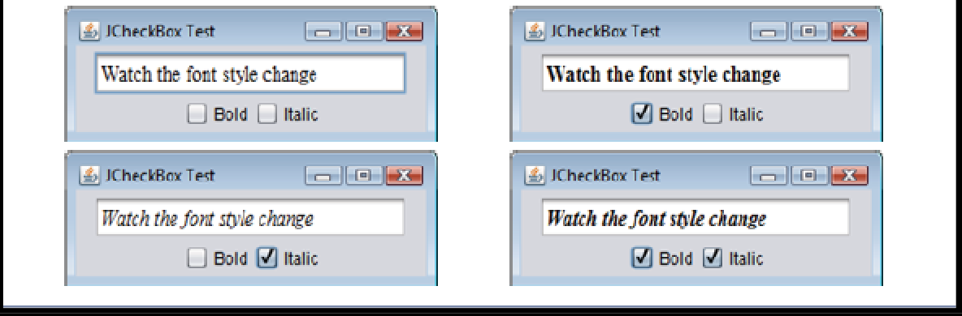

Solution:
import java.awt.*;
import java.awt.event.*;
import javax.swing.*;

public class LabTask118 extends JFrame
{
JTextField text;

public LabTask118()
{
setLayout(new GridLayout(2,1));

text = new JTextField("Watch the font style change", 25);

JCheckBox bold = new JCheckBox("Bold");
JCheckBox italic = new JCheckBox("Italic");

JPanel p1 = new JPanel();
JPanel p2 = new JPanel();

p1.add(text);

p2.add(bold);
p2.add(italic);

add(p1);
add(p2);

Font plain = new Font("Serif", Font.PLAIN, 14);
text.setFont(plain);

ItemListener handler = new ItemListener()
{
public void itemStateChanged(ItemEvent e)
{
int style = Font.PLAIN;

if (bold.isSelected())
style = style + Font.BOLD;

if (italic.isSelected())
style = style + Font.ITALIC;

text.setFont(new Font("Serif", style, 14));
}
};

bold.addItemListener(handler);
italic.addItemListener(handler);
}

public static void main(String[] args)
{
LabTask118 frame = new LabTask118();

frame.setTitle("Checkboxes Test");
frame.setSize(450,200);
frame.setDefaultCloseOperation(JFrame.EXIT_ON_CLOSE);
frame.setVisible(true);
}
}
Output:
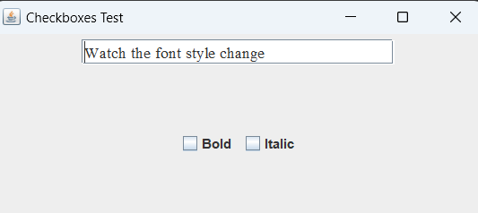
Question # 09
Make a functional nonscientific calculator. Recall the last task of the previous lab
Solution:
import java.awt.*;
import java.awt.event.*;
import javax.swing.*;

public class LabTask119 extends JFrame
{
JTextField t1;
double num1, num2;
String op;

public LabTask119()
{
JPanel p1 = new JPanel();
p1.setLayout(new GridLayout(4,4,5,5));

t1 = new JTextField();

for (int i = 7; i <= 9; i++)
{
JButton b = new JButton("" + i);
p1.add(b);

b.addActionListener(new ActionListener()
{
public void actionPerformed(ActionEvent e)
{
t1.setText(t1.getText() + e.getActionCommand());
}
});
}

JButton div = new JButton("/");
p1.add(div);

for (int i = 4; i <= 6; i++)
{
JButton b = new JButton("" + i);
p1.add(b);

b.addActionListener(new ActionListener()
{
public void actionPerformed(ActionEvent e)
{
t1.setText(t1.getText() + e.getActionCommand());
}
});
}

JButton mul = new JButton("*");
p1.add(mul);

for (int i = 1; i <= 3; i++)
{
JButton b = new JButton("" + i);
p1.add(b);

b.addActionListener(new ActionListener()
{
public void actionPerformed(ActionEvent e)
{
t1.setText(t1.getText() + e.getActionCommand());
}
});
}

JButton sub = new JButton("-");
p1.add(sub);

JButton b0 = new JButton("0");
JButton dot = new JButton(".");
JButton eq = new JButton("=");
JButton add = new JButton("+");

p1.add(b0);
p1.add(dot);
p1.add(eq);
p1.add(add);

JPanel p2 = new JPanel(new BorderLayout());
p2.add(t1, BorderLayout.NORTH);
p2.add(p1, BorderLayout.CENTER);

add(p2, BorderLayout.CENTER);

ActionListener opListener = new ActionListener()
{
public void actionPerformed(ActionEvent e)
{
num1 = Double.parseDouble(t1.getText());
op = e.getActionCommand();
t1.setText("");
}
};

div.addActionListener(opListener);
mul.addActionListener(opListener);
sub.addActionListener(opListener);
add.addActionListener(opListener);

b0.addActionListener(new ActionListener()
{
public void actionPerformed(ActionEvent e)
{
t1.setText(t1.getText() + "0");
}
});

dot.addActionListener(new ActionListener()
{
public void actionPerformed(ActionEvent e)
{
t1.setText(t1.getText() + ".");
}
});

eq.addActionListener(new ActionListener()
{
public void actionPerformed(ActionEvent e)
{
num2 = Double.parseDouble(t1.getText());

double result = 0;

if (op.equals("+"))
result = num1 + num2;
else if (op.equals("-"))
result = num1 - num2;
else if (op.equals("*"))
result = num1 * num2;
else if (op.equals("/"))
result = num1 / num2;

t1.setText("" + result);
}
});
}

public static void main(String[] args)
{
LabTask119 frame = new LabTask119();
frame.setTitle("Calculator");
frame.setSize(400,250);
frame.setLocationRelativeTo(null);
frame.setDefaultCloseOperation(JFrame.EXIT_ON_CLOSE);
frame.setVisible(true);
}
}
Output:
